LXSG-15C
Multi-jet, vane wheel, dry-dial water meter
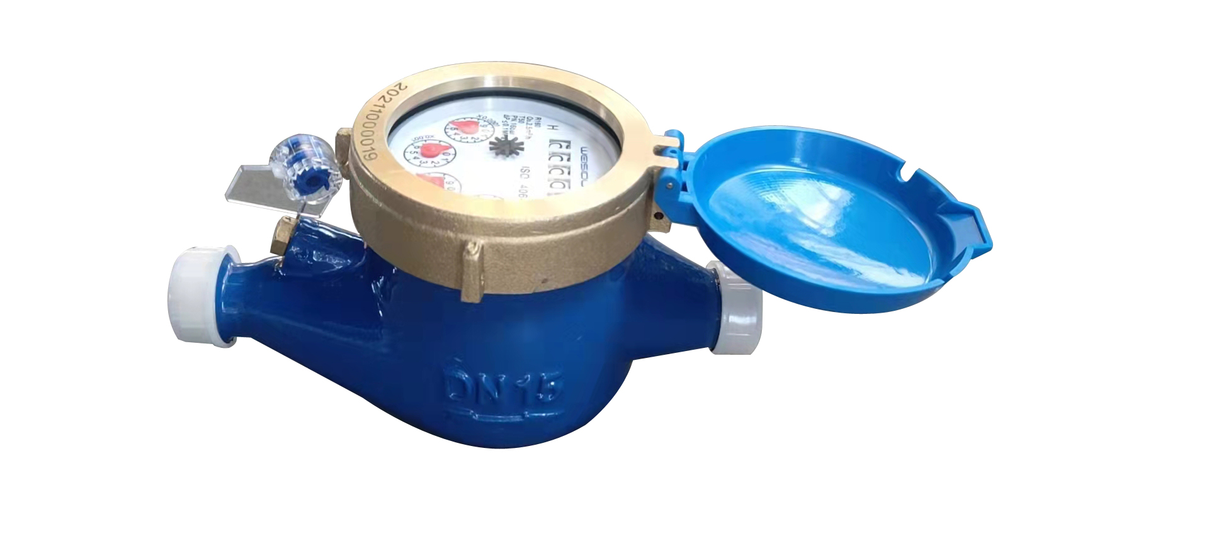

Application:
● Measuring the total volume of cold water passing through the pipeline.
NOTE:
● This type of water meter can be used for a remote reading transmission system as
equipped with a built-in-sensor.
Feature:
● Multi-jet, dry-dial; Magnetic drive;
● Vacuum sealed register ensures the dial keep free from fog and frost, Keep the reading
clear in a long term service;
● Removable measuring unit,easy installation and maintenance, Antimagnetic function;
● Measuring high flowtate with low head loss,inner and outside adjustment is optional;
● Remote transmission device can be added upon request:
such as Reed Swith or Hall, Pulse Output:1000L/P、100L/P、10L/P、1L/P;
● Technical data conform to ISO4064 standard Class C
Working condition:
● Water temperature: T30 T50
● Water pressure class: MAP16 MAP10
Maximum permissible errors:
● in the lower zone from q_{min} inclusive up to but excluding q_{t} is ±5%.
● in the upper zone from q_{t} inclusive up to and including q_{s} is ±2%;

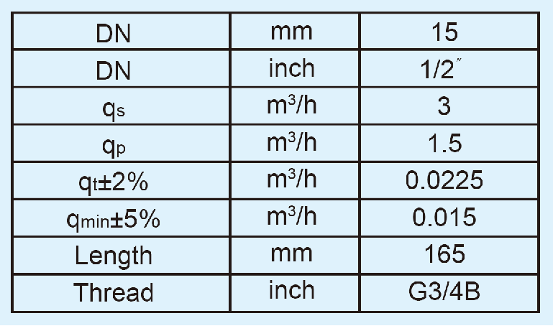
Main Technical Specification

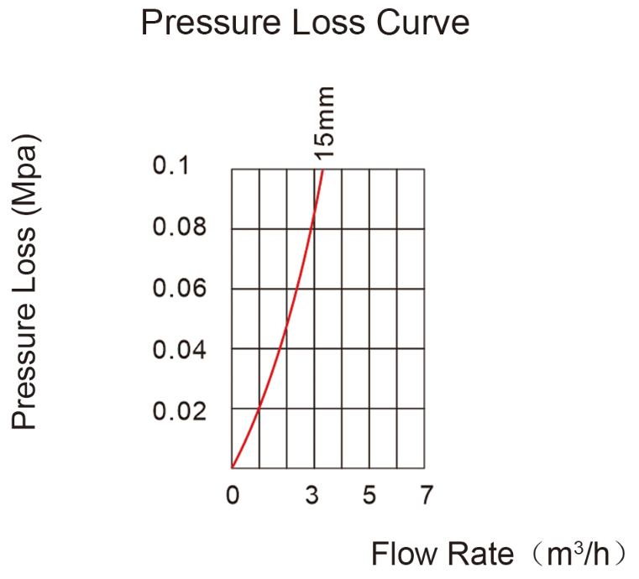
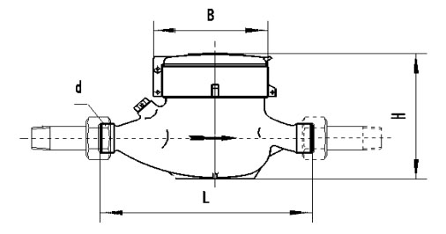
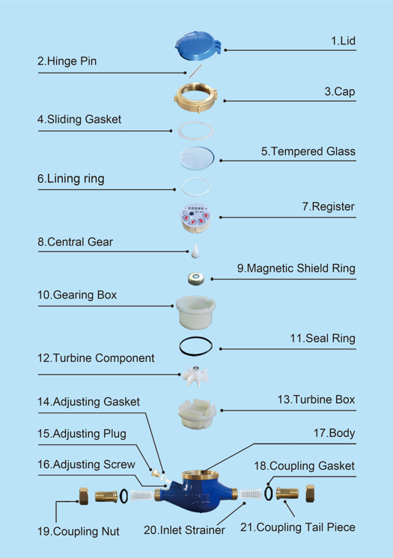
LXSG-15 MULTI-JET, VANE WHEEL, DRY-DIAL WATER METER
Code | Description | Material | QTY
1 | Lid | HDPE（ABS） | 1
2 | Hinge Pin | Stainless steel | 1
3 | Cap | Brass | 1
4 | Sliding Gasket | PP | 1
5 | Tempered Glass | PC | 1
6 | Lining ring | Plastic | 1
7 | Register | Assembly | 1
8 | Central Gear | Component | 1
9 | Magnetic Shield Ring | Iron | 1
10 | Gearing box | ABS Plastic | 1
11 | Seal Ring | Silicon Rubber | 1
12 | Turbine Component | Component | 1
13 | Turbine Box | HIPS | 1
14 | Adjusting Gasket | Nylon | 1
15 | Adjusting Plug | Brass | 1
16 | Adjusting Screw | POM | 1
17 | Body | Brass | 1
18 | Coupling Gasket | Rubber | 2
19 | Coupling Nut | Brass | 2
20 | Inlet Strainer | PP | 2
21 | Coupling Tail Piece | Brass | 2

